Project Development Phase
Model Performance Test
Date | 21 February 2025
Team ID | SWTID-2026-4574
Project Name | Script-Controlled ACL – Restrict Record Access Based on Field Value
Maximum Marks | 10 Marks
Team Size | 3
Team Leader | LOGESHWARI K T
Team Member | ALJASIRA R
Team Member | KAVIYA N

Model Performance Testing:
Project team shall fill the following information in model performance testing template.
S.No | Parameter | Values | Screenshot
1. | ACL Configuration | Script-controlled ACL is configured on the Institution Details table.  Type: record  Operation: read  Decision: Allow if  The ACL evaluates the configured field value before granting record access. | 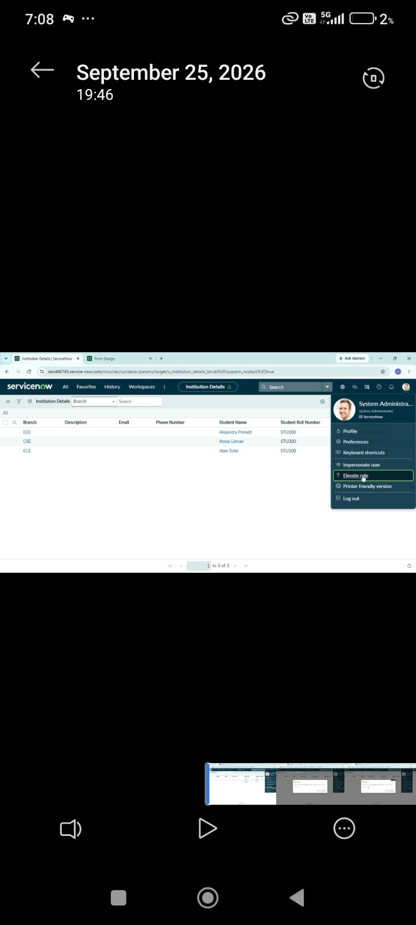
2. | Field-Based Access Validation | Access is controlled based on the Branch field value.  Authorized field value: EEE  Restricted values: CSE / ECE  The script checks the record field at request time and allows access only when the condition is satisfied. | 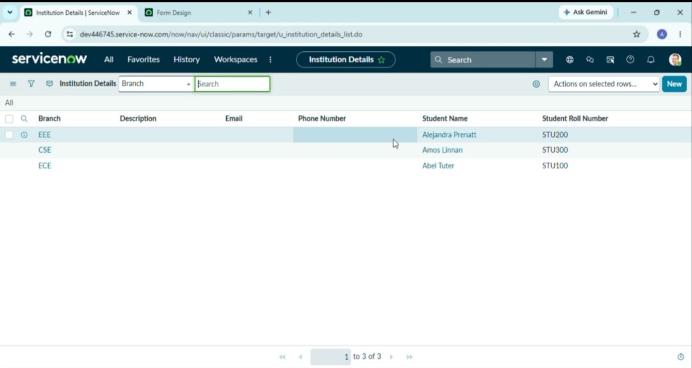
3. | Unauthorized Record Protection | When the field value does not satisfy the ACL condition, the user is prevented from accessing the protected record.  Expected Result: Unauthorized users cannot view restricted record information. | 